Plant | Variety | Description | Picture
Amaranth  Annual | Red Leaf | Medium-green, oval to heart-shaped leaves are overlaid with burgundy red. Comparable to spinach in flavor. | 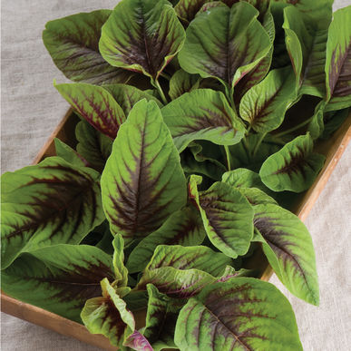
Artichoke  Perennial | Imperial Star | A green artichoke, Imperial Star will produce well-developed artichokes the first year from seed. Plants become 1 1/2-3' tall and have an open growth habit. Each typically produces 1-2 primary buds, which average 3-4" in diameter, and 5-7 smaller secondary buds. | 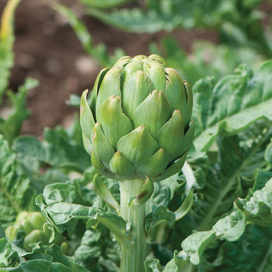
Basil  Annual | Amethyst Improved | The only purple Genovese-type basil.  Large, 2-3", thick, turned-down leaves. This stunning basil is nearly black in color. Ht. 16-20".  Use the flowers in any recipe that calls for basil, or to garnish drinks, salads, soups, pasta, and desserts. Flavor is of intense basil | 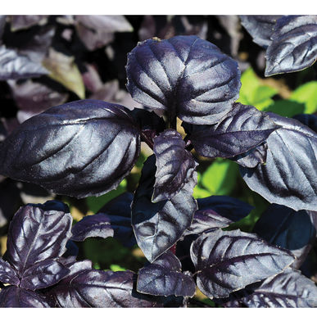
Basil  Annual | Cardinal | Thai basil with larger leaves.  Edible ornamental with showy flowers. Very uniform, upright habit. Flat, 2-3" long leaves that are larger than typical Thai types; purple stems and dark, purple-red flower bracts. Cinnamon/clove flavor with hints of anise. Slower growing and slow to bolt; needs a long, warm season for cut-flower use. Very good downy mildew tolerance. | 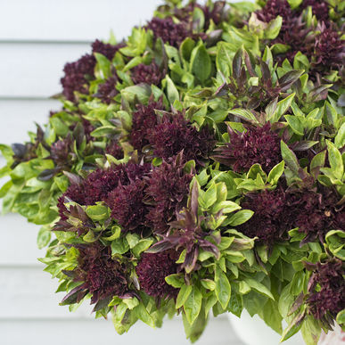
Basil  Annual | Genovese | Classic Italian variety.  Authentic flavor and appearance. Tall and relatively slow to bolt with large dark-green leaves about 3" long. Ht. 24-30".  Use the flowers in any recipe that calls for basil, or to garnish drinks, salads, soups, pasta, and desserts. Flavor is of intense basil. | 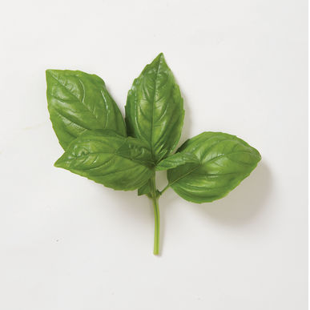
Basil  Annual | Mrs. Burns' Lemon | Sweet and tangy lemon basil.  Very bright green, 2 1/2" long leaves with white blooms make this basil both attractive and intensely flavorful. Ht. 20-24".  Use the flowers in any recipe that calls for basil, or to garnish drinks, salads, soups, pasta, and desserts. Flavor is of intense basil and citrus. | 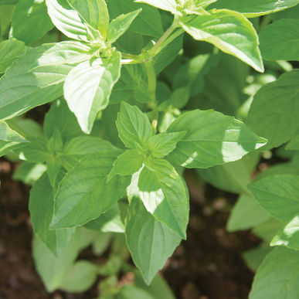
Basil  Annual | Sweet Thai | Authentic Thai basil flavor.  Try it as a flavorful garnish for sweet dishes. Green, 2" long leaves have a spicy, anise-clove flavor. Attractive purple stems and blooms. Called "Horapha" in its mother country, "Hun Que" in Vietnam. Ht. 16-20".  Use the flowers in any recipe that calls for basil, or to garnish drinks, salads, soups, pasta, and desserts. Flavor is of intense, spicy basil with notes of clove and anise. | 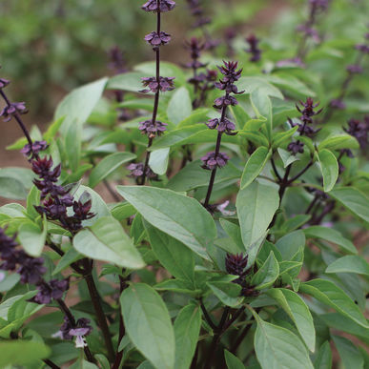
Basil  Annual | Italian Pesto | Classic variety for making pesto.  Italian basil with its glossy dark green leaves and full-bodied zesty flavor. Combine the delicious leaves with garlic, olive oil, grated cheese and toasted nuts to make homemade pesto sauce for pasta, baked potatoes or to accent fish or poultry, season soups and stews, or enhance salad dressings. | 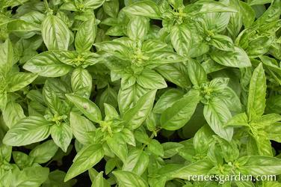
Basil  Annual | Purple Petra | A mild, sweet taste that is perfect for those who love basil’s flavor. It's excellent in a variety of dishes, including pesto, pasta, and salads and makes a lovely pink vinegar or oil. | 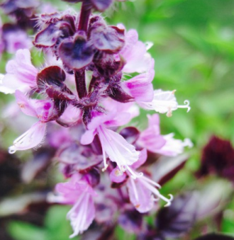
Bee Balm  Perennial | Wild Bergamot | Bright-lavender blooms with a spicy scent.  Plants produce flowers in the second year after planting.  Edible Flowers: Add petals to salads, sprinkle over mild fish, use in fruit salads, or to garnish desserts and drinks. Flavor is minty and spicy.  Nectar plant for bees, butterflies and hummingbirds. | 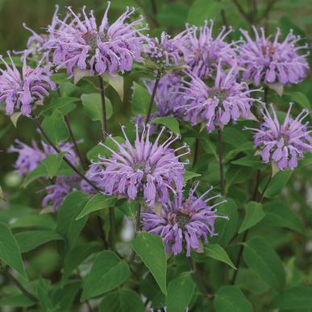
Bee Balm  Perennial | Panorama | Semi-double blooms in shades of lavender, salmon, magenta, and pale to bright pinks are useful as cut and edible flowers.  Edible Flowers: Add petals to salads, sprinkle over mild fish, use in fruit salads, or to garnish desserts and drinks. Flavor is minty and spicy.  Nectar plant for bees, butterflies and hummingbirds. | 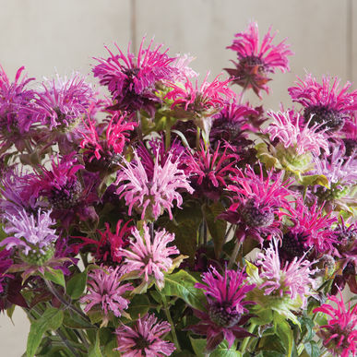
Borage  Annual |  | Large plants bear hundreds of small edible flowers, mostly blue and some pink. Long harvest period. Borage flowers attract bees and butterflies.  Edible Flowers: Add the flowers to salads or use to garnish cold drinks and desserts. Freeze as ice cubes. Mild cucumber flavor. | 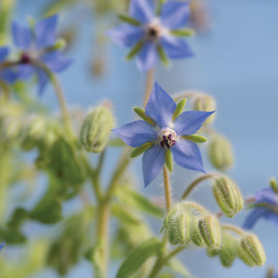
Calendula  Annual | Alpha | Clear bright-orange blooms are reminiscent of gerberas.  2 - 3 1/2" blooms. Also known as pot marigold, common marigold, and Scotch marigold.  Edible Flowers: Petals of the flowers can be used fresh or dried in "flower confetti," soups, soufflés, rice dishes, baked goods, and to garnish desserts. Calendula is a popular choice for brightening up salad mix. Flavor is tangy and slightly bitter. Remove the petals from the flower base before consuming as the base can be quite bitter. | 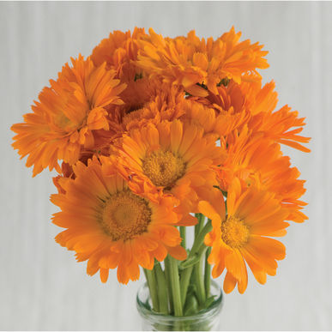
Cat Grass  Annual |  | A super source of green nutrition and fiber. Aids with digestion, helps prevent hairballs, helps prevent ingestion of potentially toxic houseplants. | 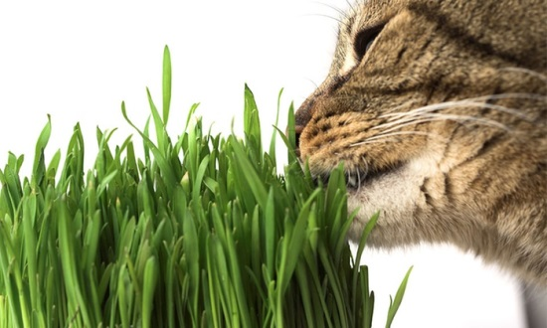
Catmint  Perennial |  | Profuse lavender blooms on spiky stems.  Good for containers and the perennial garden. Soft, crinkled, gray-green leaves on a compact, mounding plant. Attracts bees and butterflies.  Edible Flowers: The flowers are very small, but have strong flavor and aroma. Use as a flavorful garnish in any savory dish or dessert. Flavor is minty, spicy, and refreshing. | 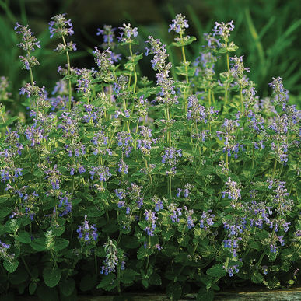
Catnip  Perennial |  | Vigorous, high-yielding plants.  Cat-attracting perennial with gray-green leaves and white flowers. Flowers are very attractive to bees | 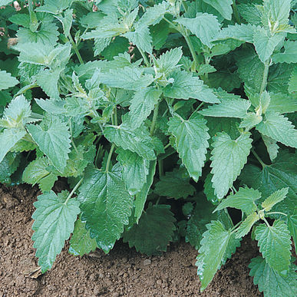
Cutting Celery  Annual |  | Leafy herb with bold celery flavor.  Use fresh in salads, cooked in soup, stew, and mixed vegetables. Also known as leaf celery. | 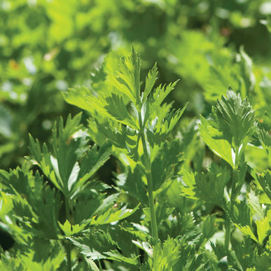
Dill  Annual | Hera | Excellent bunching dill.  Plants have a uniform habit, are slow to bolt, and produce high yields of foliage. | 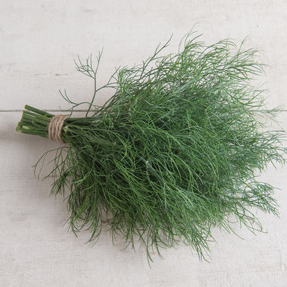
Echinacea  Perennial | Purpurea | Common purple coneflower.  The easiest Echinacea to grow. Vigorous plants with large, purple-petaled flowers. Fibrous roots are easy to harvest (other species have taproots). Attracts and is a food source for bees. Also known as purple coneflower and eastern purple coneflower. Ht. 24-36". | 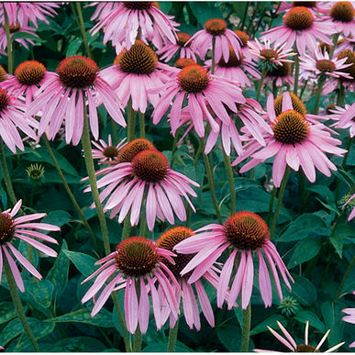
Epazote  Annual but self-seeds readily |  | Used in traditional Mexican cooking.  Pungent flavor with refreshing, minty overtones. Use in chili, sauces, and bean dishes. | 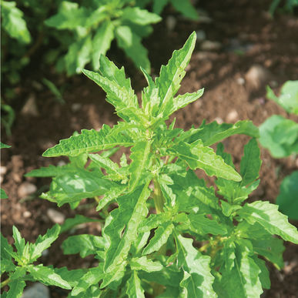
Fennel (leaf)  Annual | Grosfruchtiger | Vigorous leaf production and sweet flavor.  Non-bulbing type. Leaves are a nice addition to salads, cole slaw, and dressings.  Edible Flowers: The florets are used to garnish savory dishes, and pair well with fish, potato, tomato, and beef dishes. Flavor is of sweet anise. | 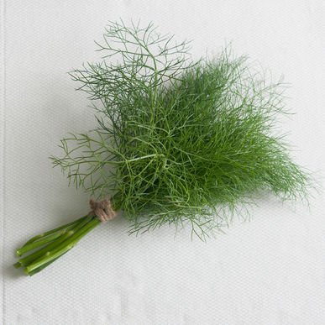
Fennel (bulb)  Annual | Orazio | Large, thick, rounded bulbs.  Crisp and flavorful with a nice anise flavor. Due to its heavier bulbs, Orazio has a higher yield potential than flatter, open-pollinated fennels. Suitable for late summer and early fall harvest in most areas. | 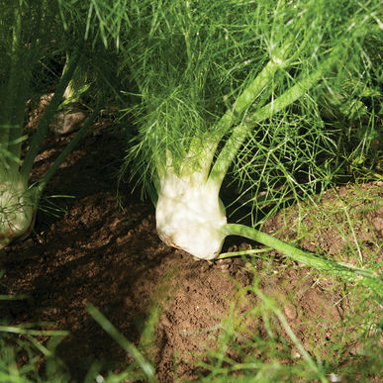
Kale  Annual | Toscano | Italian heirloom.  Lacinato or "dinosaur" type. Unique leaf type: extra-dark green, noncurled but heavily blistered (savoyed). Rich, tender leaves have a softer texture than curly green kales. Tolerant of hot and cold weather. | 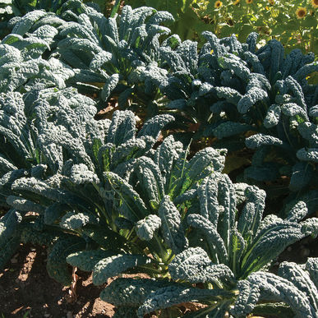
Lavender  Perennial | Munstead | Compact English lavender.  A strain of English lavender with a compact, bushy habit. Nice range of bloom colors, from pale blue to dark violet. Usually begins flowering in the second year.  Edible Flowers: The flowers can be used to garnish desserts and as a distinct flavor element in baked goods. Flavor is sweet and floral, and pair well with citrus, berries, nuts, mint, and cinnamon. | 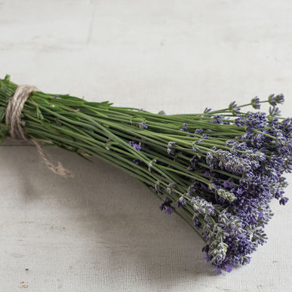
Lemon Balm  Perennial |  | Distinct lemon flavor.  Fresh leaves for tea and salads. During the summer, small white flowers full of nectar appear which attract bees. Easy to grow. | 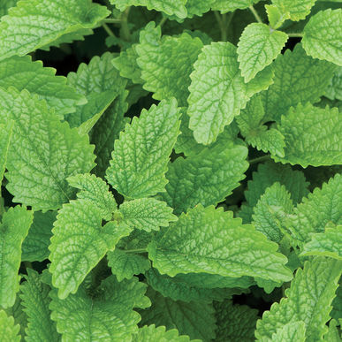
Lemongrass  Tender Perennial | East Indian | Aromatic grass from India. | 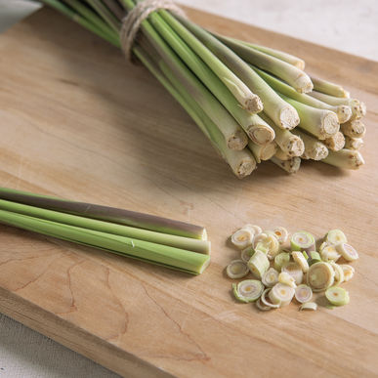
Marjoram  Tender Perennial | Sweet | Aroma is similar to oregano, but sweeter and more balsam-like. Compact plant.  Edible Flowers: Use the flowers, which have a mild and marjoram-like flavor, as you would the herb to garnish salads, soups, stews, sauces, and stuffing. Also pairs well with citrus, mushrooms, and fish. | 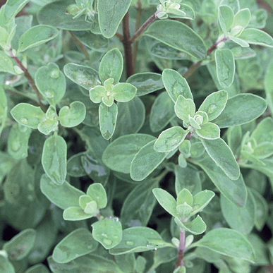
Mexican Mint Marigold  Tender Perennial |  | Aromatic leaves are a substitute for French Tarragon.  Sweet licorice flavor brightens salads and main dishes. The edible, pretty, golden-yellow flowers bloom all summer. Thrives in warmer climates where French tarragon will not grow.  Edible Flowers: Use the flowers to garnish desserts and drinks with the same sweet licorice flavor as the leaves. | 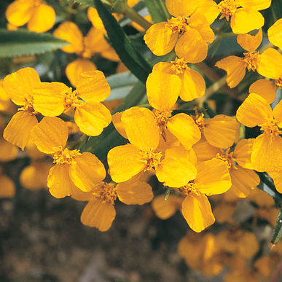
Milkweed  (Tropical)  Tender Perennial that self-seeds readily | Asclepias curassavica | Monarch host plant.  Prefers full sun but can handle a little shade. Grow from 2-4 feet tall depending on conditions. | 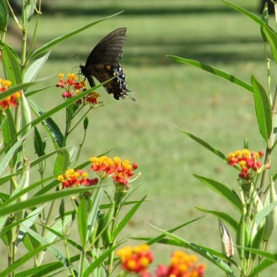
Milkweed  (Butterfly Weed)  Perennial | Asclepias tuberosa | Monarch host plant.  A native, perennial milkweed and you can expect it to die back in the fall and return each spring. Butterfly weed is drought tolerant and tough. | 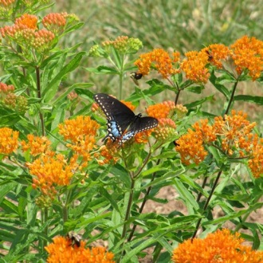
Milkweed  (silky gold)  Tender Perennial that self-seeds readily | Asclepias curassavica | Monarch host plant.  All yellow variant of Tropical Milkweed. | 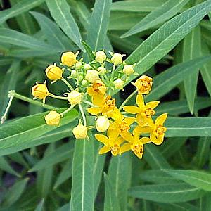
Milkweed (Whorled)  Perennial | Asclepias verticillata | Host to Monarch Butterflies.  Native nectar plant to a large variety of butterflies. | 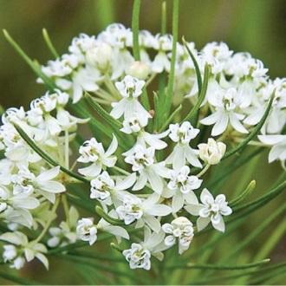
Mint  Perennial | Common | Use to flavor salad mix, main dishes, ice cream, and drinks. Variety not stated since mint does not grow true-to-type from seed.  Edible Flowers: The flowers are used to garnish salads, soups, desserts, and drinks with a minty flavor. | 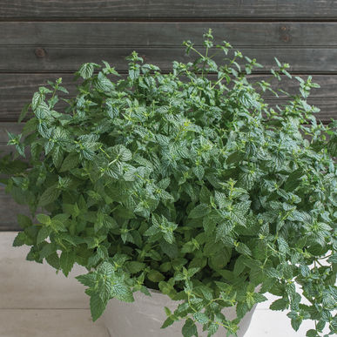
Oregano  Perennial | Greek | Strong oregano aroma and flavor; great for pizza and Italian cooking. Characteristic dark-green leaves with white flowers.  Attracts Beneficial Insects: provides pollen and nectar for beneficial insects such as bees, hoverflies, lacewing larva, parasitic wasps, and tachinid flies.  Edible Flowers: The flowers have an oregano flavor and can be used in the same manner as the herb. They are especially good in pasta salads, green salads, and as a fresh pizza topping. | 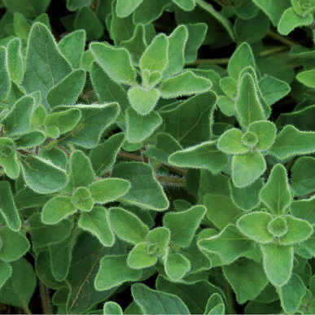
Parsley  Biennial | Giant of Italy | Huge leaves with great flavor.  Dark-green, flat leaves with strong stems. Use leaves for garnishes, salads, and cooking. | 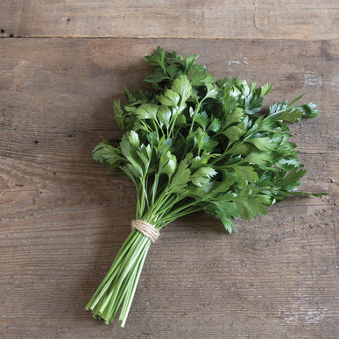
Rosemary  Perennial |  | Pine-scented, savory, culinary favorite.  Native to the Mediterranean region, rosemary has silvery, needle-like foliage and delicate flowers. Popular for potted plant sales and with chefs. | 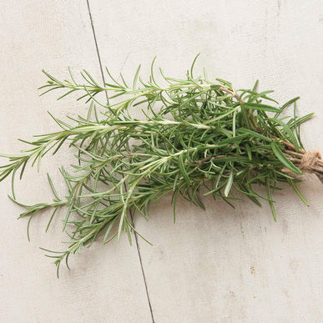
Rue  Perennial |  | Lacy blue-green ornamental.  Bushy habit is ideal for short hedges or borders. Unique and attractive foliage makes a useful cut flower filler, lasting for up to three weeks in a vase. Pungent aroma. Limited culinary use due to strong bitter flavor. | 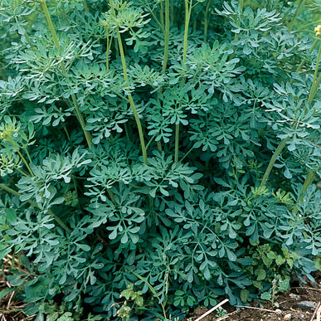
Sage  Perennial | Extrakta | Improved high-yielding variety. Robust, uniform plant. Also known as garden sage.  Edible flowers: Use as garnish, or as an ingredient in rice, egg, or cheese dishes. | 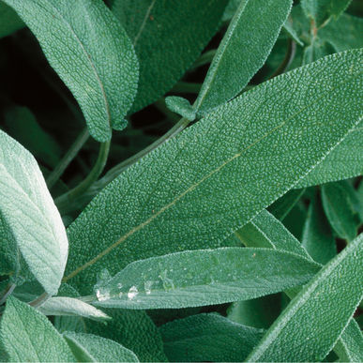
Salad Burnet  Perennial |  | Unique leaf shape for salads, garnishes.  Edible foliage has a mild cucumber flavor, and combines well with any dish that calls for cucumber. Oval-toothed leaflets and deep crimson flowerheads. Makes an attractive landscape plant. | 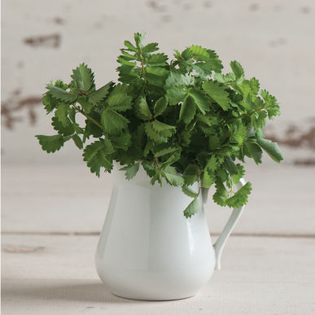
Savory  Perennial | Winter | Perennial cousin to summer savory, with thicker and shinier leaves. Flavor is more pungent and biting. Has a higher proportion of thymol than summer savory. | 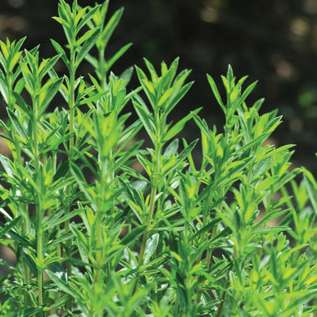
Shiso  Annual | Red | Versatile Asian culinary herb.  Distinct cinnamon/clove flavor and aroma, with the spiciness of cumin. Used in Asian cooking, sushi and salad mix. Red Shiso colors radish pickles. Also known as perilla. | 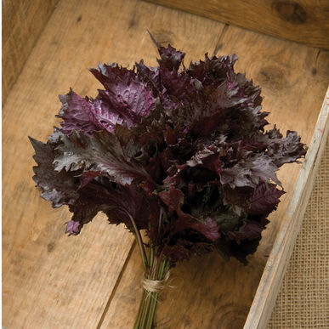
Sorrel  Annual | Red Veined | Flashy sorrel for salads.  Bright-green leaves with contrasting dark maroon stems and veins add color and taste to salad mix. Same sharp, tangy flavor as regular sorrel. Best variety for indoor production. Best when harvested young for salad mix as large leaves are tough. | 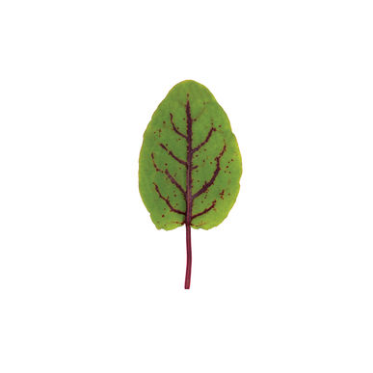
Stevia  Tender Perennial |  | Incredibly sweet leaves are an herbal alternative to sugar.  Use fresh, dried, powdered, or as a liquid to sweeten a variety of foods and beverages. Bushy, high-yielding plants. | 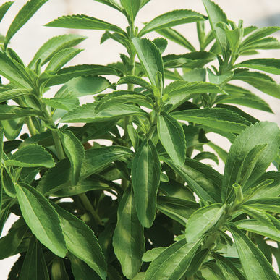
Thyme  Perennial | Creeping | Sturdy aromatic ground cover.  Slender, creeping stems and round leaves with lavender blooms. Can withstand light foot traffic and gives off pleasant aroma when walked upon. Drought tolerant once established. | 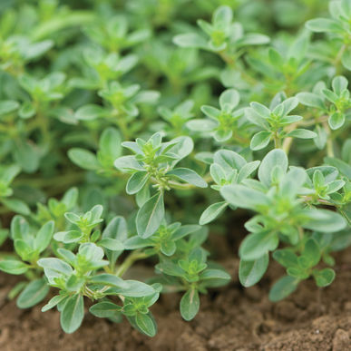
Thyme  Tender Perennial | Orange | Classic thyme appearance with a citrus flavor.  The aroma is distinctly sweeter than German Winter. Try it with fish, vegetable and perhaps even dessert dishes. | 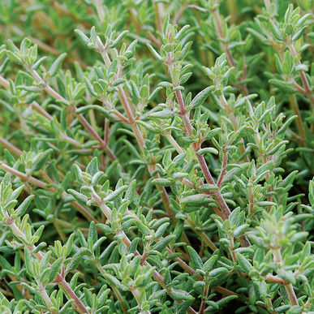
Swish Chard | Bright Lights | The gold standard for multicolored Swiss chard.  Lightly savoyed, green or bronze leaves with stems of gold, pink, orange, purple, red, and white with bright and pastel variations. Consistent growth rate and strong bolt resistance | 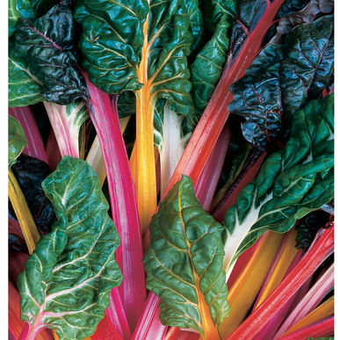
Swish Chard | Fordhook Giant | The standard green Swiss chard.  The leaves are medium green and savoyed (crinkled) with white veins and broad, white stems. | 